Breaking Your OnlyFans Addiction
  - Habit-Forming Addiction Inoculation
Cairo Copeland

Disclaimer and Caution
You are responsible for your own actions and behavior. None of this book is considered legal, personal, medical or financial advice. By continuing to read this book, you hereby indemnify and hold the author, publisher, and parent company (Reinvent Ideal, LLC) as well as its directors, officers, agents, attorneys, owners, employees and successors and assigns harmless from any loss, liability, claim or demand including reasonable (as well as unreasonable) attorneys' fees, from any loss, liability, damage and cost arising from or in any way related to any contents of this book.
You accept full responsibility and liability for actions and results from using any products, services or suggestions made inside this book and its supplemental resources.
Reinvent Ideal, LLC specifically disclaims any liability, loss or risk, personal or otherwise, incurred as a consequence directly or indirectly of the use and application of any techniques or contents of this book or manual or supplemental materials provided.
You are voluntarily participating in these activities and assume all risks of harming yourself that might occur and acknowledge it is your responsibility to decide if you want to follow the contents of this book or not.
You are responsible for yourself and release all liability from Reinvent Ideal, LLC and its owners.

Also By This Author:
Cairo Copeland is the author of multiple books for the red pill consortium. If you are a male that is not getting the results he wants out of life, you may wish to consider reading the following:
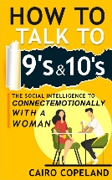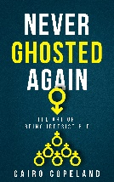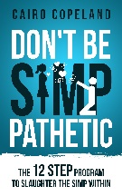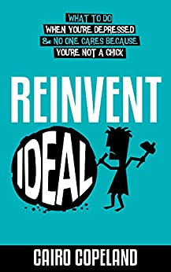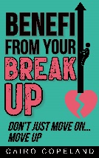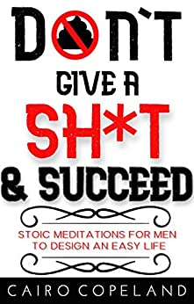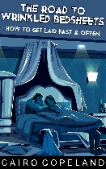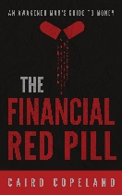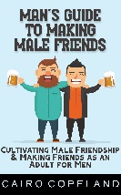
All are part of the 10-book series: The Missing Manuals to Male Success

A Free Gift For You
As a way of saying thank you for reading this book, I want to give you a free gift.
Click the link below to get your copy of this free eBook:

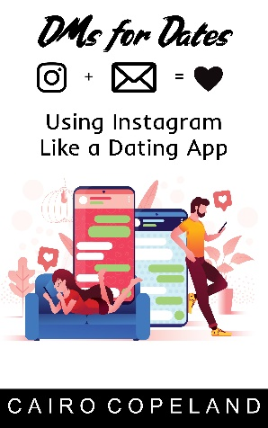
DMs for Dates: Using Instagram Like a Dating App
Click here to claim your free copy.

How to carry conversations with women you wish to date on Instagram through DMs. This works with both women you already know and with women you haven’t met yet. I will show you how to save time, avoid endless chit chat, and get her on the date sooner.

Click here to get access your free gift!

Thank you so much for reading!

Intro - Enslaved New World

If I wanted to enslave the entire world, I wouldn't do it by force, I would do it by temptations of pleasure. That is how OnlyFans enslaves males, young and old.

How OnlyFans Slowly Destroys Your Life

If you believe this habit is harmless, you must read this chapter. From the inside, it sucks you in, making you believe nothing bad is going on. But deep in the recesses of your mind, the poison is having its horrid effect.

Signs You Have a Problem

Many consumers will deny that they have a problem with the platform. They may think their use of it is just casual and low-investment. But these 7 signs would indicate otherwise. They sneak up on you and become true without you even realizing.

How They Hook You

The danger of OnlyFans is it uses the same neurological engineering used by social media and casinos. It appears to be feeding your hunger for recognition, intimacy, and interaction. But as you'll see in this chapter, the effect is illusory.

The Horrid Effects of Your Hidden Habit

Many believe that this doesn't hurt anyone at all. But the truth is a much uglier story. This chapter will show you how you're making your own life harder, how it is slowly morphing you into an insufferable person, and how it is crippling your future. Others believe this habit only hurts them, but this chapter will also show you that it hurts the entire world, socially and economically.

The Recovery

Step-by-step, I will show you the actions to take to finally break the cycle of your addiction and reclaim your life from the screen. From where to begin, to how to persist, to handling a relapse.

Insuring and Safeguarding Recovery

Once you've recovered, these 7 solid steps will ensure you stay recovered. They will be your guide in replacing the habit and preventing future cravings or relapses.

What Life is Like Once You Quit

A preview of the better life you'll soon be living.

Intro – Enslaved New World
When thinking of a dystopian future, some images and stories that immediately come to mind are ones like 1984, V for Vendetta, Hunger Games, A Clockwork Orange and Atlas Shrugged. The idea behind all these stories is an oppressive government or some other kind of ruling force enslaving the masses, plunging the world into a downward spiral to hell.

These make for incredible stories since the villain of them is so overwhelmingly powerful and the heroes we’re made to sympathize with are so powerless. It instantly sparks suspenseful anticipation because there’s a chance the bad guys could win since they are so powerful. More importantly though, the heroes are far easier for us, the audience members, to sympathize with.

We, in the real world, live under conditions we view as oppressive, such as working jobs we really don’t enjoy because we have to pay the bills. Or paying taxes to a government that spends those tax dollars disrespectfully on horse shit we don’t agree with.

Even if you love your job and agree with the wasteful agenda of your government, you can still relate because we all had to endure something that very closely resembles a concentration camp: the education system. Sent there against your will, belittled by teachers who knew little themselves, bullied by other inmates, coerced into obeying stupid rules, denied the right to use the bathroom when needed, and force-fed indoctrination that in the end was useless. That is the setting for most dystopias.

Sounds a lot like school if you ask me.

This is much like the threat in the famous 1984 where totalitarian censorship rules the world, dictates to you what to think, and restricts the availability of information only to what they approve of.
In all these, the driving element is force.

Is it possible that a dystopia could be created without the means of force? Rather, one that is brought on willfully and ignorantly so by those that will soon after become the oppressed? Much like the famous lines of Amidala in Star Wars Episode III: “This is how liberty dies? With thunderous applause?”

One author and artist of dystopic visions parted ways with his brethren in the genre and showed the world a terrifying future brought on by consumption culture. The danger this one posed was far more subtle in its method of mass enslavement. This author was Aldous Huxley. His work was Brave New World.

He portrayed a world where humans were dehumanized willfully by their own hands. A world where man subjugated himself to his own inventions. Far more in line with the realities of western culture, but also far ahead of his time, Huxley was largely forgotten during the rise of George Orwell, Ayn Rand, and the like.

In Brave New World, Huxley imagines an “attention economy” where the inhabitants actively seek continual distraction to avoid the difficult matters of daily living. Work avoidance, this is a term I’ll be referencing a lot.

The media ceases to spread information to make you know things. It trades that for spreading sentiment to make you feel things. In Huxley’s time, this was limited to descriptions of the greatest modern media achievement then, which was television. But his prophecies extend their fitness even to today’s modern media: the internet and smart phones.

You tune into them, plug into them, to feel something, to distract yourself, at the expense of what richness awaits you in the real world.

Endless quests for instant gratification and mainstreaming pornography were staples of Huxley’s vision. While in most dystopias, the people are controlled by inflicting pain, in Brave New World, they are controlled by inflicting pleasure.

Seemingly free-acting individuals enslave themselves to their own desires? Where else do we see this?
With the segment of the population addicted to OnlyFans, which is about 75 million at the time of this writing.

I will not waste your time explaining what OnlyFans is or how it works. If you picked up a book titled Breaking Your OnlyFans Addiction, you know very well what it is and how it works. But more importantly, you recognize that the future it is giving you is more dystopic or that the future it is costing you is more utopic.

Or perhaps you are still on the fence about the subject. You are a regular user of OnlyFans, spend a little money on it here and there, occasionally message the creators, keep it all a secret, and think you don’t have much of a problem. This book will convince you that yes, you do have a problem, and it’s not just you who will pay for it. The entire world will as well.

An example of the willful slavery OnlyFans facilitates with its users is best demonstrated by this screenshot of a post on 4Chan:

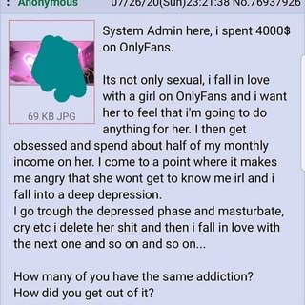

Maybe your problem is not as extreme as that guy’s. Maybe your problem is more like this guy:

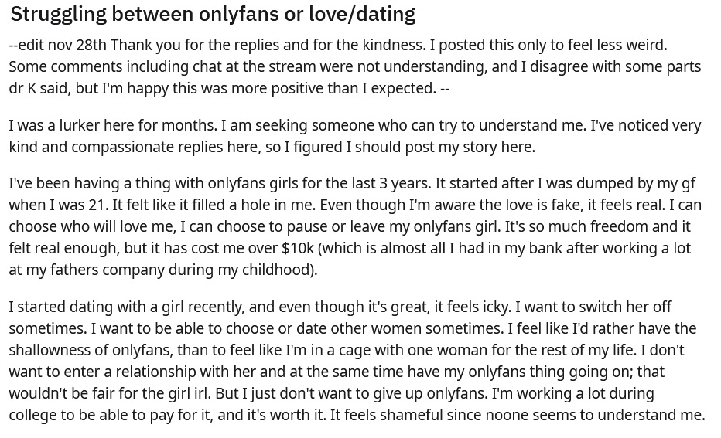

A young male who’s spent so much time in this matrix that he is no longer able to distinguish in advance the good feelings he would get from a real woman against the dopamine rushes of OnlyFans content.

The problems associated with this addiction are not just sexual, but social as well. You’ll find the weakness this addiction creates bleeding over into all aspects of your life.

Some dismiss these guys as losers or just from the lower echelon of males. But that is not true because all males are at risk, even ones who have good things going for them in their lives and fulfillment from other sources:

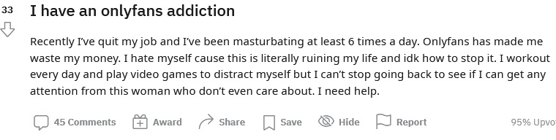

This guy works out, so he has the drive to improve himself. He has activities and interests that can be social and lead to expanding circles, like video games. While often seen as a socially isolating activity, there is a large gamer community where the inhabitants have the ability to form friendships they otherwise would never have had.

But even this guy is not safe from the lure of this poison.

That being said, even while the successful can fall prey to this predator, the trap is most dangerous for the more vulnerable among us: the poor and low-income earners. Which is a phase most guys will have to go through.

Being a young man, college-educated or not, no employer takes you seriously until you are 35 years old. It’s just a sad fact of life we have no choice to accept. Too many young guys showed up to work drunk or didn’t show up at all. So, employers view you as useless until you prove otherwise. You’ve always had this feeling your whole life that you must prove yourself and that is extra apparent here.

When you are in this poverty-phase of your youth, you have yet another problem: this is also when you are the horniest. The sight of a woman in a bikini can still give you a boner. I remember when I was in my late teens, a woman in the Baywatch Lifeguard One-piece would turn me on. So, of course it will be easy for an OnlyFans E-thot to seduce you with full-fledged porn.

As a result, the young male in the early stages of adulthood can easily waste what little money they receive, from working, on this addiction, as demonstrated by this reddit post here:

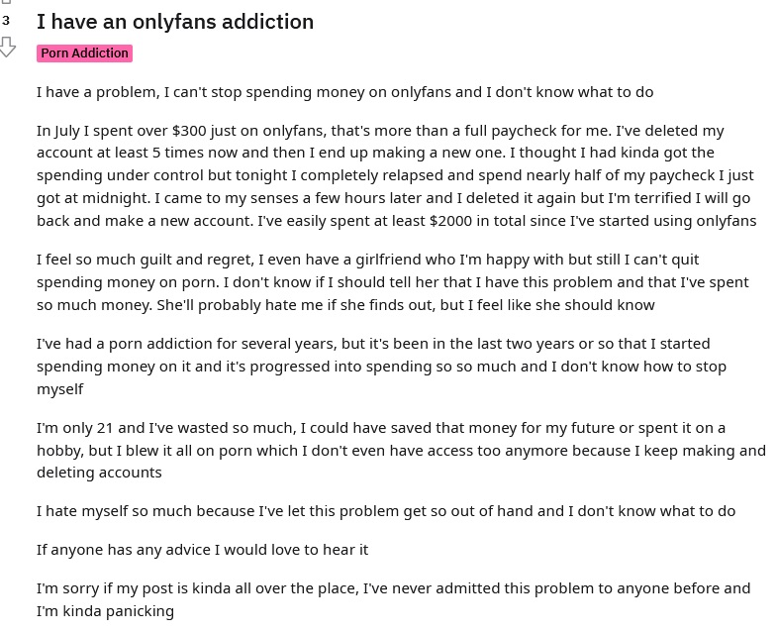

Clearly, many guys with this problem recognize what a problem it is. But they are at a loss for how to stop it. They know it’s bad for them, but they keep doing it. Much like other addictions such as cigarettes, alcohol, and drugs.

Further compounding the problem, society offers no solutions to the guys who find themselves in this hell. This is because society is ruled by a Fempowerment Mandate which demands anything that benefits a woman or womankind, even if it is at the expense of others, must be accepted, celebrated, legislated, and enforced.

Look no further than the social push to make “sex work” socially acceptable. This is not because “sex work” has any merit or benefit to society. The product of it is pure indulgence. The push exists mainly because it provides an income to otherwise talentless women that possess no other marketable or compensable skills. Or no patience to work their way up through the ranks like the rest of us.

They want easy money fast and this platform gives them that.

Ironically, this same society will still ridicule and condemn you for being an OnlyFans user. They’ll label you an incel or a loser. But when you ask society for help in overcoming it, they turn their back on you and expect you to figure it out on your own. Because of how they’ll mock you for your admission of the problem, you dare not mention it to anyone.

As society celebrates the woman that sells smut on OnlyFans, it will also eschew the guy that buys it. Many guys that broke up with their girlfriends upon discovering their girlfriends were OnlyFans grifters were later shamed by her social circle and labeled as “insecure in their masculinity” with “small dick energy.” However, being an OnlyFans user is quite evident of masculine inadequacy, in the view of the exact same critics.

That is because an adequate man would have no use for the sexual artifice OnlyFans provides. He’d have the means to get the real thing.

Still, despite society’s imperatives and mandates for you, the addict recognizes that something is still very wrong. Rest assured; you are in the right place now. And you are not a loser. Because as you will see in the pages that follow, the conditions of today’s world along with its social imperatives have created the perfect storm for a poison like OnlyFans to ensnare you in.

Step-by-step, I will show you how to escape this prison and reclaim control of your urges as well as your life. Never again will you find yourself upset with your prior poor decisions. Never again will you find yourself tempted to continue this monstrous transfer of wealth. And never again will you beat yourself up for pissing so much money away to beat yourself off.

That initial hesitancy you felt in buying this book will be the last gasp of temptation the OnlyFans operation will be able to throw at you.

Turn the page to reinvent yourself. Reinvent the wheel. Reinvent ideal.

How OnlyFans Slowly Destroys Your Life
To best illustrate the problem in an addicted user’s life, I will use this reddit post from a very honest redditor that has all the elements of the addiction outlined.

The headline for the post reads: “I’ve developed an OnlyFans addiction over the course of quarantine. I’m pretty sure I’ve spent way too much too and I don’t know how to feel.”

This title indicates that he can recognize the financial setbacks he’ll suffer from this. But he’s also conflicted because he did receive pleasurable dopamine rushes for those expenses. If the exchange we’re completely fair, would he really put all the energy into posting on reddit about it? Especially when the social imperative is to label him a loser or pathetic.

You don’t see people make “cry for help” reddit posts after fair exchanges like buying groceries or paying for movie tickets. But when it comes to attaining sexual satisfaction, the guys that pay for it know deep down that something is wrong with what they’re doing. More on that later.

The redditor continues: “So one day I was curious about OnlyFans. I have always been a fan of amateur porn, so the fact that I’d be able to directly support the girl was interesting. I do support sex work and didn’t want to continue funding bad practices in the industry using certain websites... so OF was great to me.”

The bad practices he’s referring to come from a misconception of how the porn industry recruits its performers. While early on, the industry conducted abuse of its actresses regularly, which was made famous with the Linda Lovelace case in the 70s, the smut business is far from that kind of environment today.

On the shoot of a porn flick, everyone caters to, compliments, and even bows in subservience to the female performers. This is because upsetting an actress to the point of her storming off the set or abandoning the project would result in at least $10,000 wasted in production and crew costs just one day.

Further, despite what the documentary Hot Girls Wanted would have you believe, many porn producers turn aspiring porn actresses away because they can sense the girls are only seeking easy money. Those producers don’t want future lawsuits nor the guilt on their conscious of permanently tarnishing this girl’s future because the money she’s paid will one day run out while the internet will keep her deed online forever.

The idea of using OnlyFans to directly support the creators as a moral stand because it doesn’t involve a potentially abusive middleman is incredibly flawed thinking.

Back to the post: “I thought I’d only check a profile here and there but the platform hits all boxes for the porn I’m into. Now I’m stuck on renewal for 20 different profiles”

That’s an evil genius element to the OnlyFans grift. Rather than asking you to spend $500 for the month up front, they ask for very small amounts, randomly throughout time that eventually add up. The amounts like $4.99 are so small that they seem harmless and trick you into thinking, “That’s not going to break my bank,” without you realizing you’ve spent that amount 10 times this month already.

They seem so inconsequential until you add them all up. He continues:

“I don’t even want to look at my account spendings because I feel so ashamed & would be embarrassed if one person knew about it. The fact that I’m supposedly in my prime years doesn’t make me feel better. I’m still in my 20s and seeking for a love interest doesn’t appeal to me. I have hobbies and interests that I am absolutely passionate about but I’m way too unmotivated to put in effort. Being stuck in the house doesn’t help with looking for inspiration.”

This goes to show that the problem can attack anyone. While society at large thinks only incels and losers fall for the grift, everyone can fall prey to it, even successful guys with their shit together. After all, the guy that was paying Blu Jasmine bills long after she dumped him had to have been a successful guy to afford the lifestyle she still demanded he pay for.

But here’s the larger point: despite what society says, you are not a loser if you have fallen for this temptation. There is mass conditioning and brilliant neurological engineering that went into tricking you to fall for this grift. You’re only a loser if you continue after you know the plot against you.

“The last relationship I was in was about two years ago but I haven’t really bothered since. Also, I’m pretty sure I suffer from trauma after having a toxic relationship for some years. I get matches on tinder yet all the complicated first steps just intimidate me. I’ve had tinder for a while and still haven’t bothered to try and do a date.”

This is a common complaint I hear from clients in my coaching practice and a big part of why I even had one to begin with. The dating and mating market of today is far different from the one they were promised before they were old enough to enter it.

In your grandfather’s day, the way to get a girlfriend was to be a hardworking, church-going, semi-good-looking-enough, sweet-complimenting gentleman. Those days are gone forever.

Flooded with choice, as well as displeased with the choices, today’s female inhabitants of the dating market demand much more. This problem is thoroughly outlined in Never Ghosted Again and Don’t Be Simp-pathetic. But to briefly summarize, because male thirst for sex and female intimacy is at an all-time high today, women put greater premiums on their companionship.

They will demand you not only be well off financially, but also what you do to get there needs to be something “respectable” (you can’t be a plumber or an electrician despite how respectable and well-paid those professions are). You also must be very sociable, which is getting more and more difficult in today’s increasingly insolating world. They expect you to always have something brilliant, witty, or deeply stimulating to say.

You need to have an expensive car she can be proud to be seen driven around in. You need luxury items like a boat. You need a well-established, diverse social circle of interesting people. They expect you to have incredible talents like being able to sing, play guitar, dance, fix cars, fix things around the house, fix computers and phones.

They approach the dating market like a Build-a-Bear order. All these skills like music and fixing things take a long time to acquire. One man cannot have the skills of an auto mechanic, electrician, and musician as a side dish while working a career that pays well enough to have luxury items like a boat.

Young males that are new entrants to the dating market will not have these things because they are just now entering the real world. That haven’t lived long enough to acquire these things. Especially when employers don’t take them seriously until they are 35 years old. Thus, they will not be granted access to the one thing they can’t stop thinking about (sex with women) for many years. Perhaps a decade.

This man is made more rare with the requisites of physical fitness and 6 feet in height. Tinder now has height verification. Ironically, it does not have weight verification, which is something you can actually do something about whereas height you cannot. Another example of how the world serves the Fempowerment Mandate at the expense of all else.

The end result is that many young males will gravitate to OnlyFans as their primary source of sexual satisfaction and in these early years of their sexual development and maturity, it will condition their minds to view intimacy as something to be bought. Not as a connection to be mutually built by two interested parties.

He goes on: “I’m in a big group of friends and a lot of them are dating, yet I’m over here spending my money on girls that don’t even know my face. And I don’t really spend my money on anything else since I choose not to go out as much.

“My self esteem is at an all-time low but I don’t want to worry my friends at all. It hurts how it’s natural for me to act as if I’m in tune with everyone while being around them. Haven’t really told anyone how much I’m suffering and it’s not really a visible problem. I wouldn’t even want to confide in anyone I knew about this problem because OF consumers seem to be shunned within my social circle.”

To further compound the problem, the addicted feel as though there’s nowhere they may go for help. When you make a product that people can’t help but use and are afraid to ask for help to stop using, you’ve done something extraordinarily evil.

“I do feel better about being able to support the girls I get pleasure from, but I know it’s unhealthy for my current lifestyle... I probably (and most likely) need therapy for multiple reasons.”

You won’t feel good about supporting these girls by the time you finish this book. Because you’ll soon see they are not these damsels in distress that were otherwise innocent beauties and just happened to fall on hard times to resort to OnlyFans grifting. No, these women have nothing but disgust and disdain for you. Many of them are the scum of the earth themselves. And for the few good-hearted ones that exist, your support of them is destroying what goodness is left in them.

“I miss doing social things and being surrounded by my wholesome extrovert friends that made me feel comfortable. With all of that missing, it can be pretty lonely. Spending money through OF gives me a false sense of appeasement because of how the service works. And it’s way too damn effective for me”.

Yes, the effectiveness of this grift is what makes it so dangerous for every male, even guys that you wouldn’t suspect to have this kind of problem. We continue peeling back the seductive mask of this poison by examining how this grift works so effectively.

Just like how medical professionals and researchers fight disease, they first seek to understand what a perfect engine it is. They learn their enemy inside out. So too must you to overcome this addiction rather than be overcome by it.

Signs You Have a Problem
Before I show you how the addiction solidifies its strangle-hold over you; some readers may still need to be convinced that they do in fact have an addiction.

It seems like pieces of heaven have come down to earth with this platform. Maybe that’s the case for the “content” creators. And I hesitate to call what they create “content” because their consumers are anything but content. Which is entirely the problem of this addiction: the more money spent by the consumer, the greater their loneliness is. And the greater is their thirst for more.

Many consumers of the site’s product will be slow to admit they have a problem at the addiction level. Thus, I have completed this list of 7 signs that say, “Yes, in fact, you do have a problem”. If any of the 7 signs are true for you, even just one, this is an addiction you must take seriously.

1. You feel angst about receiving and seeing updates from your chosen creators
The troubling thing about addictions is that they are accompanied by a hyper-sensitized reaction to triggers for your desire to be fulfilled. In this case, notifications about updates, new posts, and direct messages from the E-thots you follow on the site are that trigger.

Does it excite you tremendously to see a notification that the E-thot you’ve subscribed to has replied to your message? Do you feel yourself rushing into privacy to immediately open it and see what it is? What you are experiencing is a rush of dopamine that is similar to the rush of satisfying a drug craving.

You know the problem is at critical mass when you pull out your phone and see that the vibration notification was just a text from your mom and your anger arises. “Fuck you, bitch!” you might say. When this occurs, you’re in too deep.

2. It upsets you if your chosen creator takes too long to reply
Have you ever found yourself waiting for Thot-tiana to reply to the compliment you gave her on her asshole? Do you feel additional anxiety once an hour has gone by, but no response has been sent you’re way?
“Where are you? God Damn it!” you might think.

The hours turn into a day. And the struggle is real. Or so you say.

Finally, she replies with a short message like, “Lol! Thank you, babe! That makes me feel special.”

The final sentence of the message is a plant to keep you hooked on messaging her more, to keep you on the platform, and to ensure you keep checking the DMs. Because in those DMs, they’ll drop material for sale with a highly, sexually-charged description, and a hefty price-tag. It’s all neurological engineering to raise your buying temperature for such theft.

Later, I will reveal to you how the private messages on OnlyFans are the biggest scam on the internet today and you will feel incredibly foolish for ever taking part in them. But if you eagerly await for one, you have a problem.

3. More twisted niches are needed to get off
What makes the porn industry so successful is that the consumers of it can never have enough of it. Once you’ve seen an image or video once, it will never be able to satisfy you in the same amount the second time around. The same goes for the niche and category of the porn.

One subscription wasn’t enough. It goes up to two. Then three. Then more with constant tipping. But worse than the increase in money spent is the increase in how extreme the porn sought after becomes.

The mind has an insatiable hunger for novelty. Once you see the dirty video from Thot-tiana, you’ve consumed it in your mind and created a sensitivity-numbness to it. This is no different than how a joke is less funny the second time you hear it. Your mind built up a tolerance or resistance to its intended effect.

But you’re still left with wanting more. So, the next thing you seek to see is much different from the last. You seek out novelty by looking at highly fetishized and more twisted types of images and videos. Many addicts would be mortified if they were presented with the porn they look at today to their past-selves from just one year ago.

4. It’s made living with loneliness more acceptable
Some critics of the platform call it “Lonely Fans”. While they may be saying this jokingly or to poke fun at the consumers, it is far from just a joke. It’s often 100% true.

Loneliness is an unpleasant feeling and for good reason. When you feel that undesirable state of being whilst lonely, it is nature giving you an enormous sign that there’s work you need to do on yourself. Our evolutionary past has instilled in us that being alone could lead to death. For expulsion from a tribe would guarantee that fate.

It's stuck with us for another evolutionary function: peace by cooperation. If we remain desirable for others to keep around, humans are more likely to cooperate with us, leading to more progress for our species. And as you’ll see later, the most satisfying thing in this world you could ever encounter are other people.

Sadly, OnlyFans is the worst way to handle the lonely feelings. The relief you seek never truly arrives because it’s no different than scratching yourself to relief an itch. The problem becomes worse.

The pseudo-solutions dished out to you by this platform are merely staged interactions facilitated by your money. There’s no true connection between you and the E-thot. In fact, you’re not even talking to her (I’ll tell you who you’re really talking to later).

A larger problem is that even as loneliness is a painful feeling to endure through, this isn’t just some cruelty of nature. It is a gift from nature as it serves as a sign to inform you that you have some improvements to make on yourself. But you delay these improvements and hinder your ability to make them by sedating yourself with this site.

That doesn’t necessarily mean that the solution is to get a girlfriend. But what it does suggest is that there are larger, underlying problems such as troubled self-worth, directionless living, a lack of motivation, and codependency on others for happiness. What this all points back to is discomfort with who you are and being who you are.

5. You spend far too much money on it
Have you ever found yourself having to cut back on other things because you’ve spent too much money on OnlyFans? Have these things ever turned out to be essential expenses, like food and utilities?

The platform was built to encourage and capitalize on impulsivity. This is the neurological engineers out to get you again. The idea was that you’d feel like you’re in a race to win favor and approval from your chosen E-thot against other simps. So, you’d shell out more money faster to show her you are her most adoring fan.

This impulsivity will bleed over into other areas of your life as well. Worse than impulsivity is the gullibility that comes along with it. You get a DM from her describing something super-sexy. You buy it, but only jerk off to it once or twice before never watching it again.

6. You have a romantic obsession for an E-thot
OnlyFans’ success is built on the fact that it was the perfect combination of Tinder, Instagram, and PornHub. The idea that you could find yourself in the same mating market as highly-sexual, hot girls, and feel like you legitimately have a chance with her is how the nightclubs of yesteryear became profitable enterprises.
But none of the subscribers are special to their E-thots. In fact, these E-thots have repulsion and contempt for their subscriber simps. They don’t care about your personality. Only your money.

Despite the way her messages seem truly nice and flirty, you are being fooled. Time to make the big revelation: when you’re having a conversation in DMs with an E-thot, you’re actually talking to a man.

Many E-thots are repulsed at even talking to their simp subscribers. And many of them are lazy as well. Even the simple work that OnlyFans gives them is far too much work for them. Thus, they hire male managers to handle their DMs for them. And this proves very profitable for them, because males know what other males want to hear. They know what will suck you in and make you believe you’re getting lucky.

They know what you want to believe.

Yes, my friends, if you are conversing with a girl on the platform, you’re not conversing with a girl at all. It is only male managers. This is a service they can find easily and hire quickly. They all like it because it increases their money in tips. I know because I’ve dated these girls. They’ve shown me their managers and how they found them. Others have told me how much they hated talking to subscribers. It’s never what it seems.

Third party companies exist for the messaging tasks to be outsourced to. It saves her time. It makes her more money.

I must truly drive this point in. Even if it feels like a knife in your heart, I need to twist this knife as many times as I can. Because I don’t want you to suffer at the hands of amoral assholes, happy to cash in on your desperation for recognition from another human.

7. You've given up on real life romance
The most tragic thing I’ve heard in my life was a teenage boy tell me that he preferred pornography over a real girlfriend because porn could never hurt him. So short is his life experience. Yet so severe is he limiting his future because of it.

The problem with using OnlyFans as a substitute for real world love is that you’re not fulfilling your emotional needs for intimacy from women. You are artificially simulating them. And the effects of this simulation are short-lived.

This vice serves only as a band-aid to put over the horrifically bleeding laceration that is your unfulfilled need for female intimacy. No matter how perfectly-catered to you the custom video your favorite E-thot made for you is, you will always be left wanting to experience the real thing.

Not just the real sexual thing, but the underlying connection as well. The addiction to OnlyFans is proof that the connection is what’s truly desired because it simulates it.

The fact that OnlyFans images, videos, and interactions are unable to satisfy you, the fact that your mind will always crave novelty, is precisely why you should shift your pursuits to real women. Real people are sentient and infinite. There is no limit to their thoughts. They can provide you with true novelty.

You can be certain of me on this: I’m not one of those lovey-dovey, touchy-feely, Dr. Phil-type asswipes that preaches “true beauty is on the inside” bullshit your that religious minister who’s married to a fat, ugly ass bitch might believe. I wrote the damn book on how to get laid early and often. I love sexy women and sexual women. But physical attraction will never be enough to satisfy you.

Not a single woman on earth, no matter how attractive she is, could ever hope to fully, sexually satisfy a male. The male mind has an insatiable hunger for unlimited access to unlimited sexuality. You need a sexually attractive woman in your life. But not just one you want to go to bed with. Rather, one you wouldn’t mind waking up next to.

Perhaps you have low “mating market value”. For males, this comes from being short, being broke, weak, socially inept, or have other genetic misfortunes. These things may reduce your options in the mating market. However, one thing kills any chance of success in it: giving up. This is the poisonous outcome many guys today are programmed to believe is inevitable by the dreaded black pill community.

Not all who are ugly need to remain incels.

Life may be unfair, and many times may even outright suck. But by giving up, you are telling life, “Hey, it’s okay to suck.” You’re telling the universe and the lords of randomness it’s okay to fuck you over forever. Cause you’re not going to do a thing about it.

In my coaching practice, I’ve helped many such guys. Much of what they believe made them hopeless was eliminated by a set of workable fixes on their grooming and fitness habits. An improvement in their emotional intelligence and social skills also did wonders for them. For some, just learning to dance did the trick.

There is not a single guy in this world so damned to an incel fate where OnlyFans is the best he’ll have.

How They Hook You
The power of this poison cannot be understated with an addict count of 75 million. The libertarian-minded might say that welfare is a similar kind of drug because it can be easily abused and leads to greater long-term damage to its abusers because they become less willing to work. Food stamps, a form of welfare, was once greatly abused in the United States, up to 45 million users.

Even welfare abuse for coverage of an item as essential as food was not as addictive as OnlyFans.

How did this come to pass? Is it like Huxley wrote, a product of consumption culture? Partially. This consumerist mindset has conditioned many to immediately associate solving a problem or filling a need with buying a product or service. When the problem or need is female intimacy, many would love to just make the problem go away by throwing money at it.

Prostitution is not quite the solution many of these consumers would prefer to use. For one, it’s illegal in most areas. And two, there’s a lot of truth to the joke, “a man doesn’t pay a prostitute for sex. He pays so she’ll leave afterward.” Those consumers were looking for sexual satisfaction without the intimacy investment, work, and responsibility that comes along with it.

But OnlyFans provides a luring hook that is far more powerful than mere sexual thirst. The same sexual thirst can lead guys to invest in themselves, work hard to become wealthy, push hard at the gym to become ripped, or gleefully encounter social situations to become better at socializing. All these things can lead to a greater sex life.

OnlyFans’ trap weaponizes its temptation with a more primitive need: dopamine.

How do they ensnare so many guys? Three ways, the first of which is:

1. Providing the dopamine dependency of social media sites and casinos.
Dopamine has been crucial to human survival and perpetuation. In the caveman days, you got a rush of it when you found a tree with fruit hanging from it because food was so scarce. You got it when you killed a saber-tooth tiger because predators were so plentiful and life was so fragile. You got it when you won a fight with others over a cavewoman to fuck, because all throughout human history only the top 20% of all males had all the sex.

Without these dopamine rushes, there would be no motivation to venture out of the cave or to compete against others. The human race would not have survived nor perpetuated. It helped us survive in the caveman days. But since the biological evolution of human beings does not keep pace with the speed of technological development, you are at risk of falling for the grifts that seek to capitalize on this.

An enabling force behind the addiction is anticipation. When you sense something influencing you to have anticipation, alarm bells need to be ringing. OnlyFans takes extra advantage of this with their gated silos. When you first stumble onto a creator’s page, you can see the number of posts, but not the details of them. You have no idea what those posts contain until you pay to see them.

Still, after you’ve paid the subscription membership, some of them may still be blurred, requiring you to pay more. You may be able to see if it’s a photo or a video, but your mind will wonder and further crave knowing exactly what it is behind the pay wall. This craving will not be satisfied until you find out.

This is just like the text message you haven’t read yet. You get the excitement when your phone buzzes. And the good feelings persist up until you’ve finished reading and responding to it. Before that, it was a mystery box. A present under the Christmas tree. Something that could be all sorts of good things.

Other kinds of porn sites immediately reveal their content to you. On PornHub, you can see not only the thumbnail for the video, but you can even preview the video by hovering over the thumbnail and it will show you a preview of what will play. If it did not do this, you’d have no choice but to click on it. And if it charged you to see, you’d have no choice but to pay.

With the OnlyFans interface, the mystery behind the pay-wall tricks your brain into focusing on it more. The greater focus on it deepens your investment in it, thereby enhancing the "value" of it to you. The more you invest mentally into something, the more value you will assign to it, as evidenced by stock investors who believe their stocks are worth more than they really are just because they own them.

Being unable to know what the post contains, what goes on in the video, until you pay, works just like the slot machines in casinos. Have you ever noticed that the slot machine doesn’t stop all three reels at once? It stops them one at a time. Why? Because in building anticipation for each reveal of the stopped reel, the dopamine delivery is increased.

The point of them is to get you to focus on "what it could be". Another example of this is the coin games at Chuck E. Cheese, where you have a stack of coins about to fall off the edge. It looks like the next coin that goes in could be the one that tips them over and wins the whole game. It tricks you into thinking it will only take “just one more”.

Mystery box appeal was best illustrated in an episode of Family Guy when Peter Griffin was given a choice of prize between a boat and a mystery box. He exclaimed: "A boat's a boat, but the mystery box could be anything. It could be a boat!" We assign more value to the unknown because we spend more time thinking about what it could be, thereby investing deeper into it which perpetuates the additional value assignment.

Some grifters know this very well. Such as Ellie-Jean Coffey, the sexy surfer who, after seeing how easy it was to get the attention of thirsty simps, decided to capitalize on it. She opened up a pay-site, Ellie-unlocked.com, that was structured just like OnlyFans with posts hidden behind pay-walls and private messages requiring payment to see as well. But the contents of such posts and messages were merely the exact same things you would see on her Instagram profile.

Perhaps the most famous one was Bella Thorne, who raised $1 million in one day from simps that desperately wanted to see her nude. But when they bought her subscription, they were severely disappointed seeing only pictures and video of her fully clothed.

2. Falsely Feeding the Hunger for Recognition, Intimacy, and Interaction.
Suppose you were to follow a Pornstar on Instagram or subscribe to her channel on PornHub. Theoretically, it should offer you all the same content you’d have access to on her OnlyFans. But there’s something missing from these outlets: accessibility. On these platforms, your fantasy woman is completely inaccessible. Meaning she has no idea you even exist.

You’re just a number in her subscriber count.

The photos and videos uploaded may be explicit, but what’s missing from the experience is you. These platforms can have everything that her OnlyFans profile has, but it’s still everything but you. She’s aloof and unaware of your presence viewing them. In the majority of porn consumption prior to OnlyFans, it was mainly a voyeuristic experience.

But now in OnlyFans world, you and the rest of the audience are acknowledged. It may even feel like you’re the only one being acknowledged by her. Look at how often the words “you” and “your” appear in her posts. When you see those words, you don’t think of other people and assume she’s talking right to you, even if you consciously know she’s not. It’s even more powerful when the “conversation” occurs in your direct messages.

They’ll even proactively message you to ask for your reactions, opinions, etc. This creates an artificial intimacy. Many guys are at risk of falling for this trap because very rarely or not at all do women in the real world ever message them first.

The male managers for OnlyFans models (yes, it’s true, in those direct messages, you are actually talking to a man, you think a trashy model would have the intellect to figure out this grift?) understand that this artificial intimacy increases emotional investment. That emotional investment will lead you to drop more dollars.

A tactic they’ll use while pretending to be the model in the messages is where she’ll proactively message you to ask what you’re up to because she’s “bored” and just wants to talk to someone. Never before in the guy’s life has this happened, a woman initiating a conversation with him, and god damn it, it feels great the first time it happens. Especially when he responds back, and a conversation gets going.

Much like the hits of dopamine rushes a guy feels when he’s getting a good texting conversation going with a woman he matched with on a dating app, he’s sucked right it. This arrangement on OnlyFans doesn’t feel like a server/customer interaction series. It feels more like a real life, long-distance relationship, where the evidence of said relationship is all in the text messaging.

And like the damage a long-distance relationship can do to a guy, by purporting the belief that it’s anything more than an imaginary friend, more time is spent idealizing what the relationship could one day be like rather than appreciating it for what it is now. Because there’s nothing to appreciate now.

3. The Ability to Purchase Guaranteed Acceptance.
Every guy that’s ever matched with a girl on a dating app has experienced this: You send her the initial message. She responds. You send another message that’s somewhat generic and boring. She reads it. But never responds again. She effectively ghosts and disappears on you.

However, on OnlyFans, you can send the exact same kind of canned, uninteresting message, and your OnlyFans E-thot will respond. Well, her male message manager will respond. But most users don’t know that they’re talking to other men when they’re messaging their favorite E-thots.

This is doing more than just damaging your social intelligence with women. It’s damaging your social development as a person entirely.

You don't need to make yourself interesting to her or stand out. That has been the cry of every black pill incel and it has now been heard: they no longer need to be the “dancing monkey” or try hard in any way to win the woman.

The black pill incels lament the fact that in order to keep a woman’s attention, they must do all the work and constantly think of ways to keep things interesting. They put up all the effort while she puts up none. Interestingly, if that’s cause for aversion to pursue women (put in effort), why would they do anything in life (as everything demands effort, even shitting)?

We may make fun of the black pill doomers, but OnlyFans caters specifically to them. Their blue pill conditioning made them believe that women ought to and will love them for who they are. Their red pill awakening taught them that women will not. But they still yearn for their blue pill beliefs to be real. OnlyFans, and the male managers behind it, understand and exploit that.

Rarely in the real world do you find women that care for male hobbies like sports or video games. But on Onlyfans and Twitch, these women are everywhere. This is how you know a male manager is running it because very rarely do male and female interests intersect. So, for a place to be so heavily concentrated with females that have conventionally-assigned male interests, an alarm should go off telling you something is up.

But the blue pill has made the OnlyFans consumer crave this: a woman he can share all his interests, thoughts, hobbies, and feelings with. The long-lasting damage this will do is creating unrealistic expectations as well as sabotage real-world relatability.

You may also notice that the creators (or again, their male managers) create backstories of how they were outcasts or once the unpopular, nerdy girl that got picked on in school. This is a trope that many guys legitimately lived through. How is it possible for every woman selling her body and attention on OnlyFans to legitimately have this backstory?

It’s not.

The real reason they portray that image is because the male managers running the account know that males often struggle to relate to a woman they're attracted to. That is because there are vast differences in life experience for the average guy and the attractive woman.

As a male, you live in a world that has immediate, if not instant, consequences for being inadequate, being a loser, a fuckup, or a failure. If you live with your parents as an adult, you’ll be made fun of. If you act socially out-of-tune, you not only don’t get any girls, but you also don’t get any friends. If you don’t have your shit together and make yourself valuable in some way, you don’t get invited to the parties, you don’t get hired by employers, and you don’t get handouts when you panhandle without being told you’re a bum.

The world will be quick to fire you, dump you, and ostracize you for the first fuckup you make.

But when you’re a beautiful woman, people will laugh hard at every unfunny joke you tell. White knights will rush to your rescue when you encounter some kind of misfortune even if you brought it upon yourself. All a pretty lady needs to do to get validation is post a picture on social media. Or not even a picture, just post a status update saying she’s feeling down, and an army of her simp followers will dish out attempts to uplift her.

Thus, males have a difficult time relating to attractive women. But the male managers of OnlyFans E-thots have taken care of this problem by giving her a backstory similar to the typical OnlyFans addict.

In real life, there is discomfort among males while out on dates with attractive women if they cannot easily bridge the gaps of little to no mutual interests or similarities in backstories. You might have lived through one of these painfully awkward conversations where you keep trying to get a conversation going on a date but you just can’t seem to find a damn thing you and her connect on or agree about.

OnlyFans further damages your ability to bridge these gaps.

Unlike real women in the real world, your OnlyFans girlfriend seems to do her part in carrying on the conversation and maintaining her end of upholding interest back in you. She doesn't reject your less-than-stellar attempts to keep the conversation going or failures to be interesting. It all comes at a price, but there's an even deeper cost than money.

The cost is your potential at ever having any social intelligence.

It’s so bad that OnlyFans thots will even accept and positively respond to dick pics. No woman in the world worth a shit ever wants to see a picture that focuses exclusively on a guy’s dick. But on OnlyFans, they encourage it. Some thots even perform a service where they will rate your dick on a scale of 1 to 10 for a fee. Son, please understand, she’s only doing this to make money and probably barely looks at your ding-a-ling.

This is an extremely, heinous evil but also a very intelligent evil. It allows the consumer to share their biggest insecurity (“is my dick normal and nice to look at?”) with their merchant, who is a woman they are extremely attracted to, but also have that merchant respond well to hearing that insecurity and with compassion.

This is the hope of every blue pill male: to have a beautiful woman love him no matter what. He can share with her his greatest vulnerabilities and she will still love him. They desperately want their deepest insecurity to not impact their relationship with said woman as well. For many guys, this is the closest thing they will ever come to experience that resembles unconditional love.

Try doing this in the real world with a real woman. You will soon be sorry. There’s a good reason why the red pill consortium encourages males to never be vulnerable with their wives and girlfriends.

Herein lies the deepest danger of OnlyFans. Regular porn, both free and paid, offers arousal and orgasm. Those are merely ancillary effects of a relationship with a woman, meaning there’s more to being in a relationship with a woman than the physical pleasure that comes from her body.

OnlyFans however offers that physical pleasure plus a 100% guaranteed intimate connection without the possibility of frustration or rejection. It has the potential to provide the other aspects of a relationship males want besides the sex.

Porn is sexual communism. In communism, the confiscation and redistribution of results kills the motive to produce results, which is why it has failed everywhere it’s been tried. Porn gives the false simulation that the reproductive problem has been solved, thus motivation to achieve anything is missing.

It’s no accident that since porn became more easily accessible over the internet that things have become less meritorious. Notice how everything coming out of Hollywood the last 20 years is a repeat? Notice how the American economy is losing to China? Or how even today’s architecture looks ugly and inferior to architecture of our past?

This is because many males feel no motivation to accomplish anything substantial when their original motivating force for doing so (impressing and winning the love of women) is substitutionally fulfilled by porn. OnlyFans heightens the damage this can do to a male and society at large because while porn only temporarily fulfills sexual thirst, OnlyFans can temporarily and artificially fulfill emotional thirst.

Establishing intimate relationships with women and getting them to love you is extremely difficult. Further, these relationships require heavy maintenance, and they are even more difficult to maintain than they are to acquire. Now, for a price, you get to bypass all that.

For a price, you get a sex-obsessed girlfriend in an imaginary-long-distance-relationship that loves you no matter what so long as you bring her money. You don't have to listen to her problems, deal with her drama, raise her illegitimate kids, or endure her nagging. None of the things you’d experience with a real-life woman. Plus, if she ever gets fat, loses her beauty, or stops being sexual with you, it’s easy to breakup with her. You just cancel your subscription instead of having a difficult conversation.

The tragedy of this is that the more you pay for an artifice of this, the less likely you will experience it in the real world.

Strangely, not all OnlyFans consumers are incels. Some are even in relationships. For these guys, what they are seeking is an escape. But an escape from what? Their relationship? Last I checked, the best escape from that was to break up.

But that by itself is very difficult to do. It takes emotional resolve and strength. And males truly hate doing it because males are the true romantics, contrary to popular belief. It’s commonly thought that women are the more romantic of the two sexes. Why? Because they consume more romance novels and romantic comedies? Who the hell do you think creates those?

Everyone could easily name love songs that were written by males. But it would take some serious thinking and effort to name half that many written by females. The same with poems. The work of art that is synonymous with the romantic ideal, Romeo & Juliet, was written by a male. Most acts of romance, from thoughtful dates to wedding surprises, are planned out by the male in the relationship.

Because males are the true romantics, breaking up does not come easily for them. It is painful to tell a woman, even a complete cunt, you don't wish to see her anymore. By going to OnlyFans for an escape from your relationship, you weaken your resolves as well as enhance your life misery by allowing a cause of it to remain in it.

Using OnlyFans to fulfill sexual dissatisfactions you have in your current real-life relationship only keeps your relationship unsatisfying.

That is perhaps the great power of this vice. It keeps guys in a place where they know they are not happy, by temporarily tricking them into thinking they are happy. The mind of said male is weakened tremendously. And as a result of his weakened mind, he will suffer. So too will the world at large.
And that is the next thing to be discussed: the horrific effects this hidden habit has on you and the world around you.

That’s it for this free sample…

I hope you’ve found what you’ve read so far to be valuable and intriguing. If it has been enjoyable so far, I promise you there is more value and utility for you in the remainder of the book. Available on Amazon and Audible.

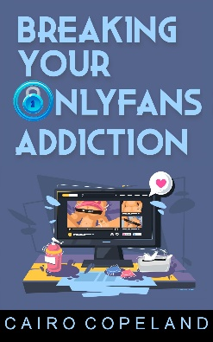

Buy from Amazon

Listen for free on Audible

Thank you very much for reading and giving us a chance to win your readership.

